

Aspire Go 16

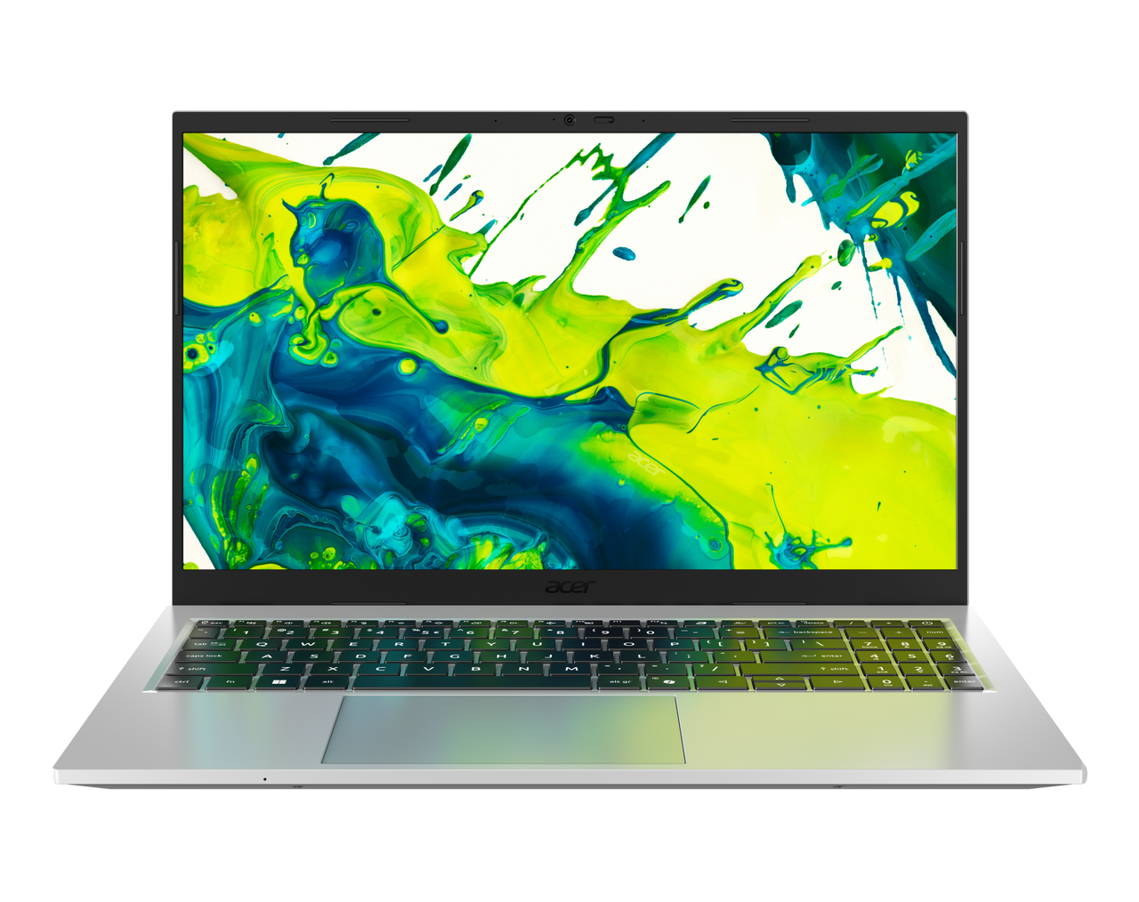

 |  | SPECIFICATIONS |  |  |  | Aspire Go 16 |  |  |  | AG16-I51P | AG16-I51PT
 |  | 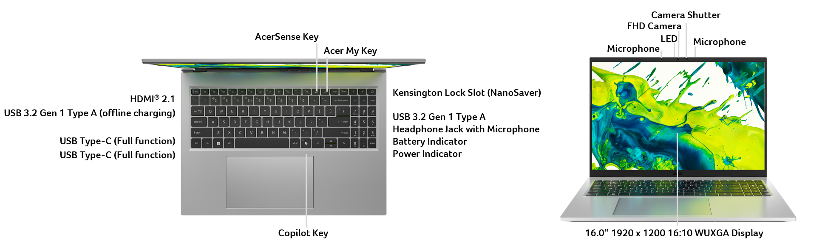
 |  | Operating System |  | Windows 11 Home
 |  | CPU and Chipset |  | Intel® Core™ 7 processor 350 |  |  | Intel® Core™ 5 processor 320 |  | Intel® Core™ 5 processor 315 |  | Intel® Core™ 3 processor 304
 |  | Memory |  | DDR5 SDRAM support | Up to 16 GB of DDR5 system memory |  |  |  |  | Memory Frequency: Up to 5600 MT/s
 |  | Display |  | 15.6" display with IPS (In-Plane Switching) technology | Full HD 1920 x 1080 | High brightness | Acer ComfyView™ LED-backlit TFT LCD  16:9 aspect ratio | 45% NTSC color gamut | Wide viewing angle up to 170 degrees | Ultra-slim design | Mercury free | Environment friendly |  |  |  |  | 15.6" display | Full HD 1920 x 1080 | High brightness | Acer ComfyView™ LED-backlit TFT LCD  16:9 aspect ratio | Ultra-slim design | Mercury free | Environment friendly
 |  | Graphics |  | Intel® Graphics eligible  Graphics Special Technology: AVC, VP9, AV1 HW Accelerated Video Decode | AVC, AV1 HW Accelerated Video Encode | Microsoft DirectX 12 | OpenGL 4.6 | OpenCL 3.0
 |  | Audio |  | Acer Purified.Voice technology with AI noise reduction in dual built-in microphones. Features include far-field pickup, dynamic noise reduction through neural network, adaptive beam forming, and pre-defined personal and conference call modes. |  |  |  |  | Acer Ultra Boost Speaker Module with 50% PCR chamber design by embedded smart amplifier output with Acer TrueHarmony technology for lower distortion, wider frequency range, headphone-like audio and powerful sound  SDCA (Soundwire Device Class Audio) Driver supported
 |  | Storage |  | Solid state drive: 512 GB / 1 TB, PCIe Gen4, 16 Gb/s, NVMe
 |  | Webcam |  | Video Conferencing  UFC with Double T-Type USB FHD Camera | Compatible with Windows only | 1920 x 1080 resolution | 1080p HD video at 30 fps with Temporal Noise Reduction | 86 x 3.2 (4.2) x 3 mm | Blue glass lens | Dual Mic (33 mm + 33 mm)
 |  | Wireless and Networking |  | WLAN:  Intel® Wireless Wi-Fi 6E AX211 | 802.11 a/b/g/n/ac/ax wireless LAN | Band: 2.4 GHz, 5 GHz, and 6 GHz |  2x2 MU-MIMO technology | Intel® Connectivity Performance Suite (ICPS) |  |  |  |  | WPAN:  Supports Bluetooth® 5.3 or above
 |  | Security |  | Kensington lock (Nano-type) | Camera shutter
 |  | Dimensions and Weight |  | Dimensions  357.7 (W) x 234.4 (D) x 17.99 (H) mm (14.08 x 9.23 x 0.71 inches) |  |  |  |  | Weight  1.5 kg (3.31 lbs.) with 3-cell battery pack
 |  | Power Adapter and Battery |  | Power Adapter  USB Type-C 65 W PD AC adapter | PCR 50% | TCO 9.0  Output power | 5 V / 3 A | 9 V / 3 A | 12 V / 3 A | 15 V / 3 A | 20 V / 3.25 A  90.0 (W) x 51.0 (D) x 28.5 (H) mm | 3.54 x 2.01 x 1.12 inches  192 g ± 10% | 150 cm DC cable  Black color | Acer logo | Brick type AC pins |  |  |  |  | Battery  53 Wh | 3-cell Li-ion battery | Fast charging support  For models with Full HD panel | Up to 7 hours battery life based on MobileMark® 2030 test results | Up to 13 hours battery life based on video playback test results | Up to 13 hours battery life based on web browsing test results
 |  | Input and Control |  | 99 / 100 / 103 keys | Acer backlit keyboard layout | Numeric keypad | International language support | SR05P  Slim design | 1.3 mm key travel  Dedicated AcerSense key  Programmable key | My Key  Enlarged keycaps  Adjustable backlight brightness  Quiet design for noise reduction  Caps Lock indicator  Microphone mute indicator  Function Lock key |  |  | 99 / 100 / 103 keys | Acer keyboard layout | Numeric keypad | International language support | SR05P  Slim design | 1.3 mm key travel  Dedicated AcerSense key  Programmable key | My Key  Enlarged keycaps  Quiet design for noise reduction  Caps Lock indicator  Microphone mute indicator  Function Lock key |  | Touchpad  Multi-gesture touchpad | Two-finger scroll | Pinch gesture | Gestures to open Cortana | Action Center | Multitasking | Application commands  Microsoft Precision Touchpad certification  Moisture resistant |  | Control keys  Media control keys printed on keyboard | Volume up | Volume down
 |  | Windows Desktop Apps |  | In-House Applications  Acer LiveArt | Tools  Acer My Key Application |  |  | Search  AcerSense
 |  | Warranty |  | One-year International Travelers Warranty (ITW)
 |  | Disclaimers
 |  | • | Specifications vary depending on model.
 |  | • | Shared system memory may be allocated to support graphics, depending on system memory size and other factors. Actual system memory available to the operating system will be reduced by any memory used by the graphics solution and resources required by the operating environment.
 |  | • | Memory speed may vary, depending on the CPU, chipset or memory fitted.
 |  | • | All brands and product names mentioned herein include trademarks of their respective companies and are used solely to describe or identify the products.
 |  | • | Not all features indicated are supported on all SKUs
 |  | • | 1 GB is 1 billion bytes. Actual formatted capacity is less and may vary depending on preloaded materials and operating environment. Acer Recovery Management uses a portion of the stated hard disk capacity as dedicated backup space.
 |  | • | Minor variations in system dimensions are possible due to the manufacturing process.
 |  | • | Weight may vary depending on product configuration, vendor components, manufacturing variability, and selected options.
 |  | • | Listed battery life is based on testing using video playback. The test clip loops and continues to run, without interruption or any other inputs, until the battery is drained. Stated battery life is for comparison purpose only. Actual battery life varies by model, configuration, applications, video chip format and features used. A battery's maximum capacity decreases with time and use. Battery life test configuration: Intel® Core™ 5 Processor 320, Intel® UHD Graphics, FHD, HDD only, 16GB of DDR5 memory. Battery life test condition: LCD brightness 150 nits, connected headphones, WLAN off, Bluetooth off and Better Battery Mode on.
 |  | • | Listed battery life is based on testing using Web browsing. The test clip loops the loading of 50 selected websites using Microsoft Edge every 30 seconds, until the battery is drained. Stated battery life is for comparison purpose only. Actual battery life varies by model, configuration, applications, video chip format and features used. A battery's maximum capacity decreases with time and use. Battery life test configuration: Intel® Core™ 5 Processor 320, Intel® UHD Graphics, FHD, HDD only, 16GB of DDR5 memory. Battery life test condition: 100 nits LCD brightness, 50% speaker volume, WLAN on, Bluetooth on, no WW direct Internet connection.
 |  | • | Actual battery life may vary considerably by specifications, depending on product model, configuration, applications, power management settings, operating conditions, and features utilized. Performance variation also arises based on components in use, which includes but is not limited to the processor, RAM capacity, storage, display and resolution, etc.
 |  | • | Bundled software may vary depending on hardware configuration, OS and regional availability.
 | Product Sheet is based on Aspire AG15-I51P (Win11) Specifications (v4-0-4) (Preview)
In a continuing effort to improve the quality of our products, information in this document is subject to change without notice. Images shown are only representations of some of the configurations available for this model. Availability may vary depending on region.
As a phenomenon known to thin-film transistors (TFTs), liquid crystal displays (LCDs) commonly exhibit a small number of discoloration dots, as so-called "non-conforming pixels." This phenomenon is a limitation of TFT LCD technology, not a product defect, and as such is not covered by Acer's warranty.
© 2026. All rights reserved.
Microsoft and Windows are registered trademarks of Microsoft Corporation.
3D XPoint, Agilex, Altera, Arc, Arria, Avalon, Axxia, Barefoot Networks, the Barefoot logo, the Footsie logo, Celeron, Cyclone, Docea, DoubleShot, eASIC, easicopy, FlexRAN, Gaudi, Granulate, Hyperflex, Intel, the Intel logo, Intel Adaptix, Intel Agilex, Intel Atom, Intel CoFluent, Intel Core, Intel Evo, Intel Geti, Intel Inside, the Intel Inside logo, Intel Optane, Intel RealSense, Intel SpeedStep, Intel Tiber, Intel Unison, Intel vPro, Iris, Killer, Linutronix, MAX, Movidius, Myriad, Nios, OmniBridge, OpenVINO, the OpenVINO logo, Pentium, Quartus, Simics, SmartByte, SoftSilicon, Sound Mark, StarPro, Stay With It, the Engineering Stay With It logo, Stratix, the Stratix logo, The Journey Inside, Thunderbolt, the Thunderbolt logo, Tofino, Ultrabook, VTune, and Xeon are trademarks of Intel Corporation or its subsidiaries.

About Acer
Founded in 1976, Acer is one of the world's top ICT companies with a presence in more than 160 countries. As Acer evolves with the industry and changing lifestyles, it is focused on enabling a world where hardware, software and services will fuse with one another, creating ecosystems and opening up new possibilities for consumers and businesses alike. Acer's 7,500 employees are dedicated to the research, design, marketing, sale, and support of products and solutions that break barriers between people and technology. Please visit www.acer.com for more information.

